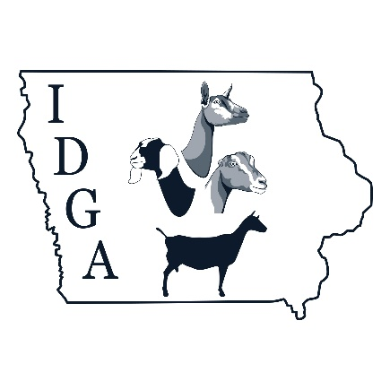
President
Butch Sowers
Vice President
John Wiebold

Board of Directors
Aaron Lehmkuhl
James McDaniel
Robyn Van Wyk
Autumn Wild
Rich Hanson

2025 IDGA Board of Directors Meeting
Saturday, October 05, 2024

Agenda: Assign Secretary and Treasurer
Approve bank account signers

President, Butch Sowers(BS), called meeting to order after elections during the IDGA Annual Meeting on Saturday, October 05, 2023. Meeting was held at the Colo Community Center and via Zoom.

Board members present: James McDaniel(JM), Aaron Lehmkuhl(AL), Rich Hanson(RH), Autumn Wild(AW), Robyn VanWyk(RVW), Vice President -John Wiebold (JW)

BS motions to appoint Phillip Jass as Treasurer. Seconded by JW. Passed unanimously.

BS motions to retain Beth Konen as Secretary. Seconded by JM. Passed unanimously.

BS motions to remove Wendy Peffers and James McDaniel as signers on the IDGA accounts. Seconded by JW. Passed unanimously

JW motions to have president (Dan “Butch” Sowers), vice president(John Wiebold), and treasurer(Phillip Jass) as signers to the IDGA account. Seconded by AL. Passed unanimously.

BS motions to adjourn. Seconded by AL. Passed unanimously.

IDGA Board of Directors meeting adjourned on Saturday, October 05, 2023.

